UNITED NATIONS

DM BHUTAN

Leaving Nii One Behind

UN/RCO/2O21 7 September 2021

*'tl?* Zf xZzcz

Subject: Submission of the Bhutan Country Proposal for the project Building Resilient Commercial

Smallholder Agriculture (BRECSA)

I write with reference to the sixth GAFSP call for proposals of 20 May 2021 in the context of the ongoing COVID 19 global pandemic.

On behalf of the Agriculture Sector Working Group (ASWG) in Bhutan, and in my capacity as the U.N. Resident Coordinator, I am pleased to convey that the project Building Resilient Commercial Smallholder Agriculture (BRECSA) to be implemented in the Royal Kingdom of Bhutan was reviewed by the ASWG and that it is complementary with development cooperation partner priorities and does not duplicate other ongoing government of development partner activities. The project is timely, and addresses some of the key constraints in the agriculture sector, especially in context of the post-COVID 19 recovery process.

The ASWG is pleased to note that the International Fund for Agricultural Development (IFAD) will assume the role as the Investment Supervising Entity, the World Food Programme (WFP) as the Supervising Entity for Technical Assistance, and the Ministry of Agriculture and Forests of the Royal Goyernm ent j)f Bhutan as the lead implementing agency for this project.

We look forward to this proposal receiving a positive outcome in the GAFSP competitive process.

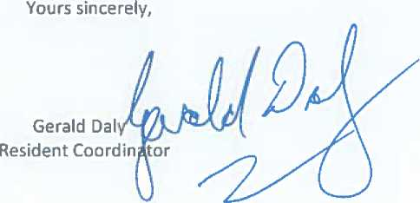

UN Resident Coordinator's Office, UN House, Peling Lam, Kawajangsa, Thimphu Bhutan P.O. Box 162